ICICI Performance Test Strategy

Digital Engagement Hub
Non Functional Testing
Detailed Test Plan
Version 1.0
Document Modification Control
Date | Author | Role | Version | Comments
30/11/2020 | Rishabh Dwivedi | Senior Performance Engineer | 0.1 | Draft Version
01/12/2020 | Rishabh Dwivedi | Senior Performance Engineer | 0.2 | Updated as per internal review comments given by Balaji
02/12/2020 | Rishabh Dwivedi | Senior Performance Engineer | 0.3 | Updated as per second internal review comments given by Balaji
03/12/2020 | Rishabh Dwivedi | Senior Performance Engineer | 0.4 | Updated as per third internal review comments given by Balaji
04/12/2020 | Rishabh Dwivedi | Senior Performance Engineer | 0.5 | Shared Version
14/12/2020 | Rishabh Dwivedi | Senior Performance Engineer | 0.6 | Updated as per review comments from walkthrough call and incorporated the prioritized list of scenarios
22/12/2020 | Rishabh Dwivedi | Senior Performance Engineer | 1.0 | Approval email attached
Table of Contents
1. Project Overview 3
2. Performance Test Strategy 3
2.1 Performance Test Scope 3
2.2 High Level Strategy 4
2.3 NFR Traceability Matrix 5
3. Transaction Volumes for Testing 5
3.1 Online Transaction Volumes 5
3.2 Batch Transaction Volumes 6
4. Test Data 6
4.1 Data Required 6
4.2 Test Account and Access Required 6
5. Detailed Test Approach 6
5.1 Execution Phase 6
5.2 Performance Tests 7
5.2.1 Batch Test 7
5.2.2 Load Test 7
6. Testing Risks, Assumptions and Dependencies 8
7. Test Environment 9
7.1 Production VS Performance Test Environment 9
7.2 Virtualization 10
7.3 Test Tools 10
8. Overall Test Schedule 10
9. Appendix 10
9.1 Document References 10
9.2 Document Approval/Signatures 11
9.3 Distribution List for Information 11

Project Overview
Digital Engagement Hub (DEH) is a strategic application within the bank hosted on cloud native architecture and containerized approach based on micro services residing on prem.
As part of the early performance test consulting, it was confirmed that, DEH is a key impacted application for this release and Wipro’s QA performance team need to execute load test to validate that the application shows no signs of performance degradation. Please refer to the email confirmation in Appendix Section 9.1 Item#1.
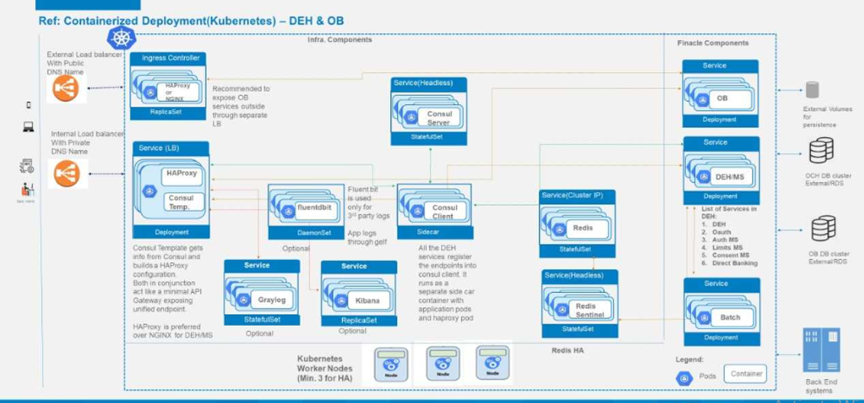
A detailed architecture of DEH can be seen in the document attached in Appendix Section 9.1 #2

Performance Test Strategy

2.1 Performance Test Scope
In total, 105 APIs of DEH have been identified to be in scope of the performance test however, these need to be prioritized given the timelines and scope of this activity. Please see the email confirming the prioritized scenarios in Appendix Section 9.1 #4
S. No. | Impacted  Application | Non Functional Tests Scope
S. No. | Impacted  Application | Performance  Testing | OAT |  | NPNFT |  | Security
S. No. | Impacted  Application | Performance  Testing | Core | Supplementary | Accessibility | Compatibility | DAST
1 | DEH

# | Test Type | Scope | Rationale | Owner
Performance
1 | Load Test | In Scope | Load test will be executed to replicate “live-like” scenario and validate the application performance. | Wipro Performance Test Team
2 | Batch Jobs | In scope | Batch testing is required to validate if the system is able to process required number of transactions in required duration. | Test/Support Team
3 | UI Performance Testing | Out of Scope | As part of this release only API testing is in scope. | NA
4 | Test Data Preparation | Out of Scope | Required test data (RR pairs, a/c no, sort code etc.) will be made available to the Wipro Performance test team | AO Team
5 | Performance Monitoring | In Scope | Performance Monitoring is in scope and will be done using Prometheus. | IBM Support Team
6 | Performance Tuning | In Scope | Performance Tuning is in scope. Dev Team will fix the performance issues based on the test results. | Dev Team

2.2 High Level Strategy
Below are the different types of performance tests which will be performed to cover the scope.
- Batch Test will be executed (by Dev) to validate <<# of payments>> are loaded & processed in <<x hours>>.
- Load Test will be executed with 105 APIs in isolation to mimic a live like scenario
  - JMeter Scripts will be used to invoke these APIs as depicted in the diagram below
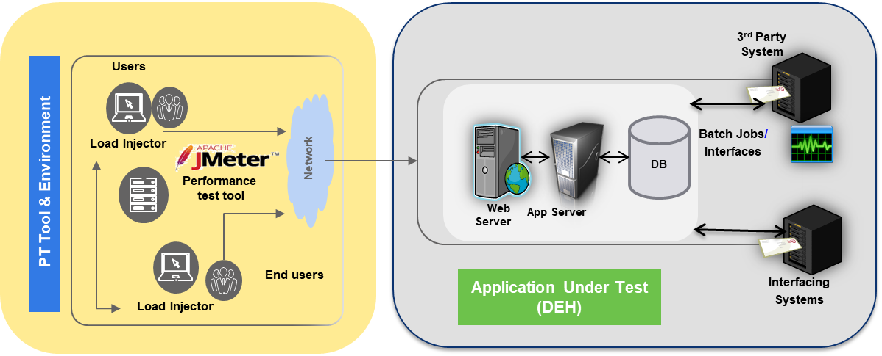

  - Impacted APIs will be tested against the volumes mentioned in section#3
  - Test will be executed with incremental TPS approach (50, 100, 150, 200…), if the APIs are not able to withstand the projected load

Note: As confirmed by Siva, these APIs have not been tested before and these test results will act as a baseline and will be used for comparing against the benchmark performance test runs. Please refer to the email confirmation in Appendix Section 9.1 Item#1.

2.3 NFR Traceability Matrix
The following NFRs are in scope of the test.
NFR Reference | NFR Type | NFR Description | Acceptance Criteria
NFR01 | Batch Requirements | Dev will execute a batch test with 4 batch jobs.  <<x records>> need to be processed in <<x hours>> | Anticipated Batch Criteria  GREEN: Processing of <<x transactions>> should be completed within <<x hours>>  RED: Processing of <<x transactions>> is NOT completed within <<x hours>>
NFR02 | Performance - Speed | To ensure that the performance of APIs is not degraded. | Response Time  GREEN: Response time of all API transactions is less than <<x seconds>>  RED: More than 5% of transactions take more than <<x seconds to process>>
NFR03 | Performance – Capacity | To ensure that the resource utilization is not degraded. | CPU Utilization  GREEN: Average application server CPU should be <= 45% for (Active- Active) and <=90% for (Active-Passive) configuration.  RED: If the utilization is more.

Performance Test Planned | NFR ID
Performance Test Planned | NFR01 | NFR02 | NFR03
NFTPT01 – Load Test
NFTPT02 – Batch Test

Transaction Volumes for Testing

3.1 Online Transaction Volumes
Prioritized APIs (as agreed) will be tested with the following volumes (specified in the doc) for a steady state of 1 hour.

However as specified above, if the APIs are not able to withstand the projected load, test will be executed with incremental TPS (50, 100, 150, 200…) for each API and results will be baselined.

3.2 Batch Transaction Volumes
<< Details of batches will be shared by Siva. Dev Team will run these batch jobs>>

Test Data

4.1 Data Required
Test Type | Data Type | Data refresh b/w tests  Y/N | Data Supplied By
NFTPT01 – Load Test | RR Pairs | N | Dev Team
NFTPT02 – Batch Test | << Dev >> | N | Dev Team

Performance test environment (UAT) will be loaded with a mix of production cut and manufactured data before start of the testing.

4.2 Test Account and Access Required
To commence performance test, access to the ICICI n/w (User Name and Password) and UAT environment should be given to the testing team and consultants.

Detailed Test Approach

5.1 Execution Phase
Entry Criteria
- The test plan must be fully approved by the relevant stakeholders. This sign off means the signatories have agreed to the scope, volumes, processes, acceptance criteria, support and overall test approach and strategy.
- Dedicated environment (configurations similar to production) is made available to execute performance test.
- Data validation and smoke tests are completed in order to evidence that the test environment is in a suitable state to start the test.
- Required test data is populated in the test environment.
Exit Criteria
- Acceptance criterion are met. If not, risks with appropriate mitigating actions are raised and agreed with all stakeholders.
- All defects are closed or accepted.
- Any issues observed have been explained and must not materially impact the performance or acceptance criteria.
- Any residual risk is documented and agreed.
- Test results have been published and signed off.

5.2 Performance Tests

5.2.1 Batch Test
NFT Reference | NFTPT02_Batch Test
NFR Reference | NFR 01, 03
Tools required | <<SSH>>
Volume | Peak
Description | The results of this test will be used to verify whether the batch test can be completed <<x hrs.>>
Test Design | Batch/Job Name | # of Records
# of Rounds | 2
Metrics | Batch Load Time, CPU & Memory Utilization of Servers
Acceptance Criteria | - CPU and Memory should be within accepted limits, as specified in Section 2.3.

5.2.2 Load Test
NFT Reference | NFTPT01_Load Test
NFR Reference | NFR 02, 03
Tools required | JMeter
Volume | Peak
Description | - A load test scenario will be executed with all the APIs running in isolation for a steady state of 1 hour to validate application’s performance.  - APIs performance observed from these runs will be baselined.  - CPU and Memory utilisation of servers will be monitored during (if applicable) or post the test.
Test Design | Ramp Up | <<x user or x TPS >> every 2 seconds
Test Design | Steady State | 1 hours
Test Design | Ramp Down | <<x user or x TPS >> every 2 seconds
Test Design | Script Names | <<TBU – when scripts are ready>>
# of Rounds | 2
Metrics | Transaction Response Time, CPU & Memory Utilization of Servers
Acceptance Criteria | - Response time of all APIs will be calculated.  - CPU and Memory should be within accepted limits, as specified in Section 2.3.

Testing Risks, Assumptions and Dependencies
Risks
ID # | Risk Title | Risk Description | Impact | Status | Severity | Probability | Mitigation
1 | Stable Code Base | There’s a risk if performance is not tested on a stable code base. | The risk would increase the test efforts and timelines due to repeated testing. | Open | Critical | Medium | - Ensure the build is completed as per the plan  - All the code is system tested with 100% coverage and 100% pass
2 | High API Count | There’s a risk on timelines if all 105 APIs have to be tested in this release. | The risk would increase the test efforts and may impact timelines. | Open | Critical | Medium | - P1 APIs can be included in scope of test for this release  - Other APIs can be tested in forthcoming releases.
3 | Performance Engineering | There’s a risk since performance engineering or monitoring tools are not available. | The risk would increase dependency on ICICI Infra team for metric monitoring. | Open | Critical | Medium | - Utilizing client server side metrics  - Taking support from infra team to monitor the required stats
4 | Open Defects | There’s a risk if there are open P1/S1 or P2/S2 defects from SIT. | The risk would increase the test efforts and timelines due to repeated testing. | Open | Critical | Medium | - Performance test to begin only when SIT has completed 50% with no open P1/S1 or P2/S2 defects.

Assumptions
ID # | Assumption Title | Assumption Description | Status | Severity | Owner
1 | Component Configuration | DEH application configurations in UAT environment will be similar to Production. | Open | Critical | DEH application owner
2 | Data Dependency | All the required data (dependent or independent) for testing the APIs will be made available to performance test team. | Open | Critical | DEH application owner
3 | Script Usage | The existing JMeter scripts currently being developed and used for SIT, can be reused in NFT. | Open | Critical | DEH application owner / ICICI SIT Test Team
4 | Poor API Performance | While doing the incremental TPS test, if the application is not able to withstand lower load, further runs will be stopped and will only be resumed post tuning. | Open | Critical | DEH application owner

Dependencies
ID # | Dependency  Title | Dependency Description | Status | Severity | Owner
1 | Support Teams | The relevant support teams (such as Dev, Stub, ITS (MQ, MB – if applicable), DB etc.) are in place and available to support testing. | Open | Critical | ITPM
2 | Application Access | Wipro Performance Team must have access to the DEH performance test environment (UAT) and DB for validation of results (if applicable). | Open | Critical | ITPM

Test Environment

7.1 Production VS Performance Test Environment
As confirmed by Siva, DEH performance test environment (UAT) is only 25% scalable to production. Given the infrastructure constraints, the volumes will be scaled down to 25% for the test execution. Please refer to Appendix Section 9.1 #3 for an email confirmation on the same.
Node Type | Suggestive Configuration | Quantity
App Prod | Intel 6248 R, 16 GB memory per core, 8*10 GBPs ports, 4 TB SSD | 8
Admin App | Intel 5222 , 16 GB memory per core, 8*10 GBPs ports, 1 TB SSD | 2
App UAT | Intel 6248 R, 16 GB memory per core, 8*10 GBPs ports, 2TB SSD | 2
OCP Prod | Intel 6248 R, 16 GB memory per core, 8*10 GBPs ports, 4 TB SSD | 3
OCP UAT/Dev | Intel 6248 R, 16 GB memory per core, 8*10 GBPs ports, 4 TB SSD | 2
App staging | Intel 6248 R, 16 GB memory per core, 8*10 GBPs ports, 2TB SSD | 2
DB | IBM AIX P9 – 24 cores ( 2 year sizing) Prod | 2
DB UAT | IBM AIX P9 ( 2 years) 5 cores | 2
Internal DB | IBM AIX P9 (2 years) 18 cores Prod | 2

7.2 Virtualization
DEH will be tested in standalone mode with all other host systems/components virtualized. These virtualized components are already in place and are hosted on-prem. Please refer to the email confirming the same in Appendix Section 9.1 Item#1.

7.3 Test Tools
# | Activity/Phase | Tools
1 | Script Creation and Performance Test | JMeter
2 | Performance Monitoring | Prometheus
3 | Functional Validation | Postman
4 | Defect Raising | JIRA

Overall Test Schedule
The business outlined a set of deliverables to be delivered and hence the project is spilt into multiple phases.
# | Phase | Start Date | End Date | Deliverables
1 | Test Strategy Phase | 26/11/2020 | 04/12/2020 | Test Plan & Strategy Document
2 | Functional Understanding and Environment Readiness | 07/12/2020 | 09/12/2020 | NA
3 | Build Phase | 10/12/2020 | 18/12/2020 | Test Scripts & Test Data Validation
4 | Test Execution & Interim Reports | 21/12/2020 | 29/12/2020 | DSRs & Progress Report
5 | Final Reporting | 30/12/2020 | 31/12/2020 | End of Test Report

Appendix

9.1 Document References
# | Document | Version | Location/Attachment
1 | Early Performance Consulting – Minutes of Meeting | 0.1 | 
2 | Detailed Architecture | 0.1 | 
3 | Environment Scalability | 0.1
4 | Prioritized List of Scenarios | 0.1 | 

9.2 Document Approval/Signatures
# | Name | Role | Email | Version | Approval
1 | Siva Palle | Application Owner/ BA | siva.palle@ext.icicibank.com | 0.6
2 | Ramnath Krishnamoorthy | ICICI Manager | ramnath.krishnamoorthy@icicibank.com
3 | Savitha Nallasami | DEH Test Advisor | savitha.nallasami@wipro.com | 0.6
4 | Balaji Kasinathan | Non Functional Test Consultant | balaji.kasinathan@wipro.com | 0.6
5 | Avinash Agnihotri | DEH Test PM | avinash.agnihotri@wipro.com | 0.6

9.3 Distribution List for Information
# | Name | Role | Email | Version
1 | Balaji Kasinathan | Test Consultant | balaji.kasinathan@wipro.com | 0.6
2 | Rishabh Dwivedi | Senior Performance Engineer | rishabh.dwivedi@wipro.com | 0.6

